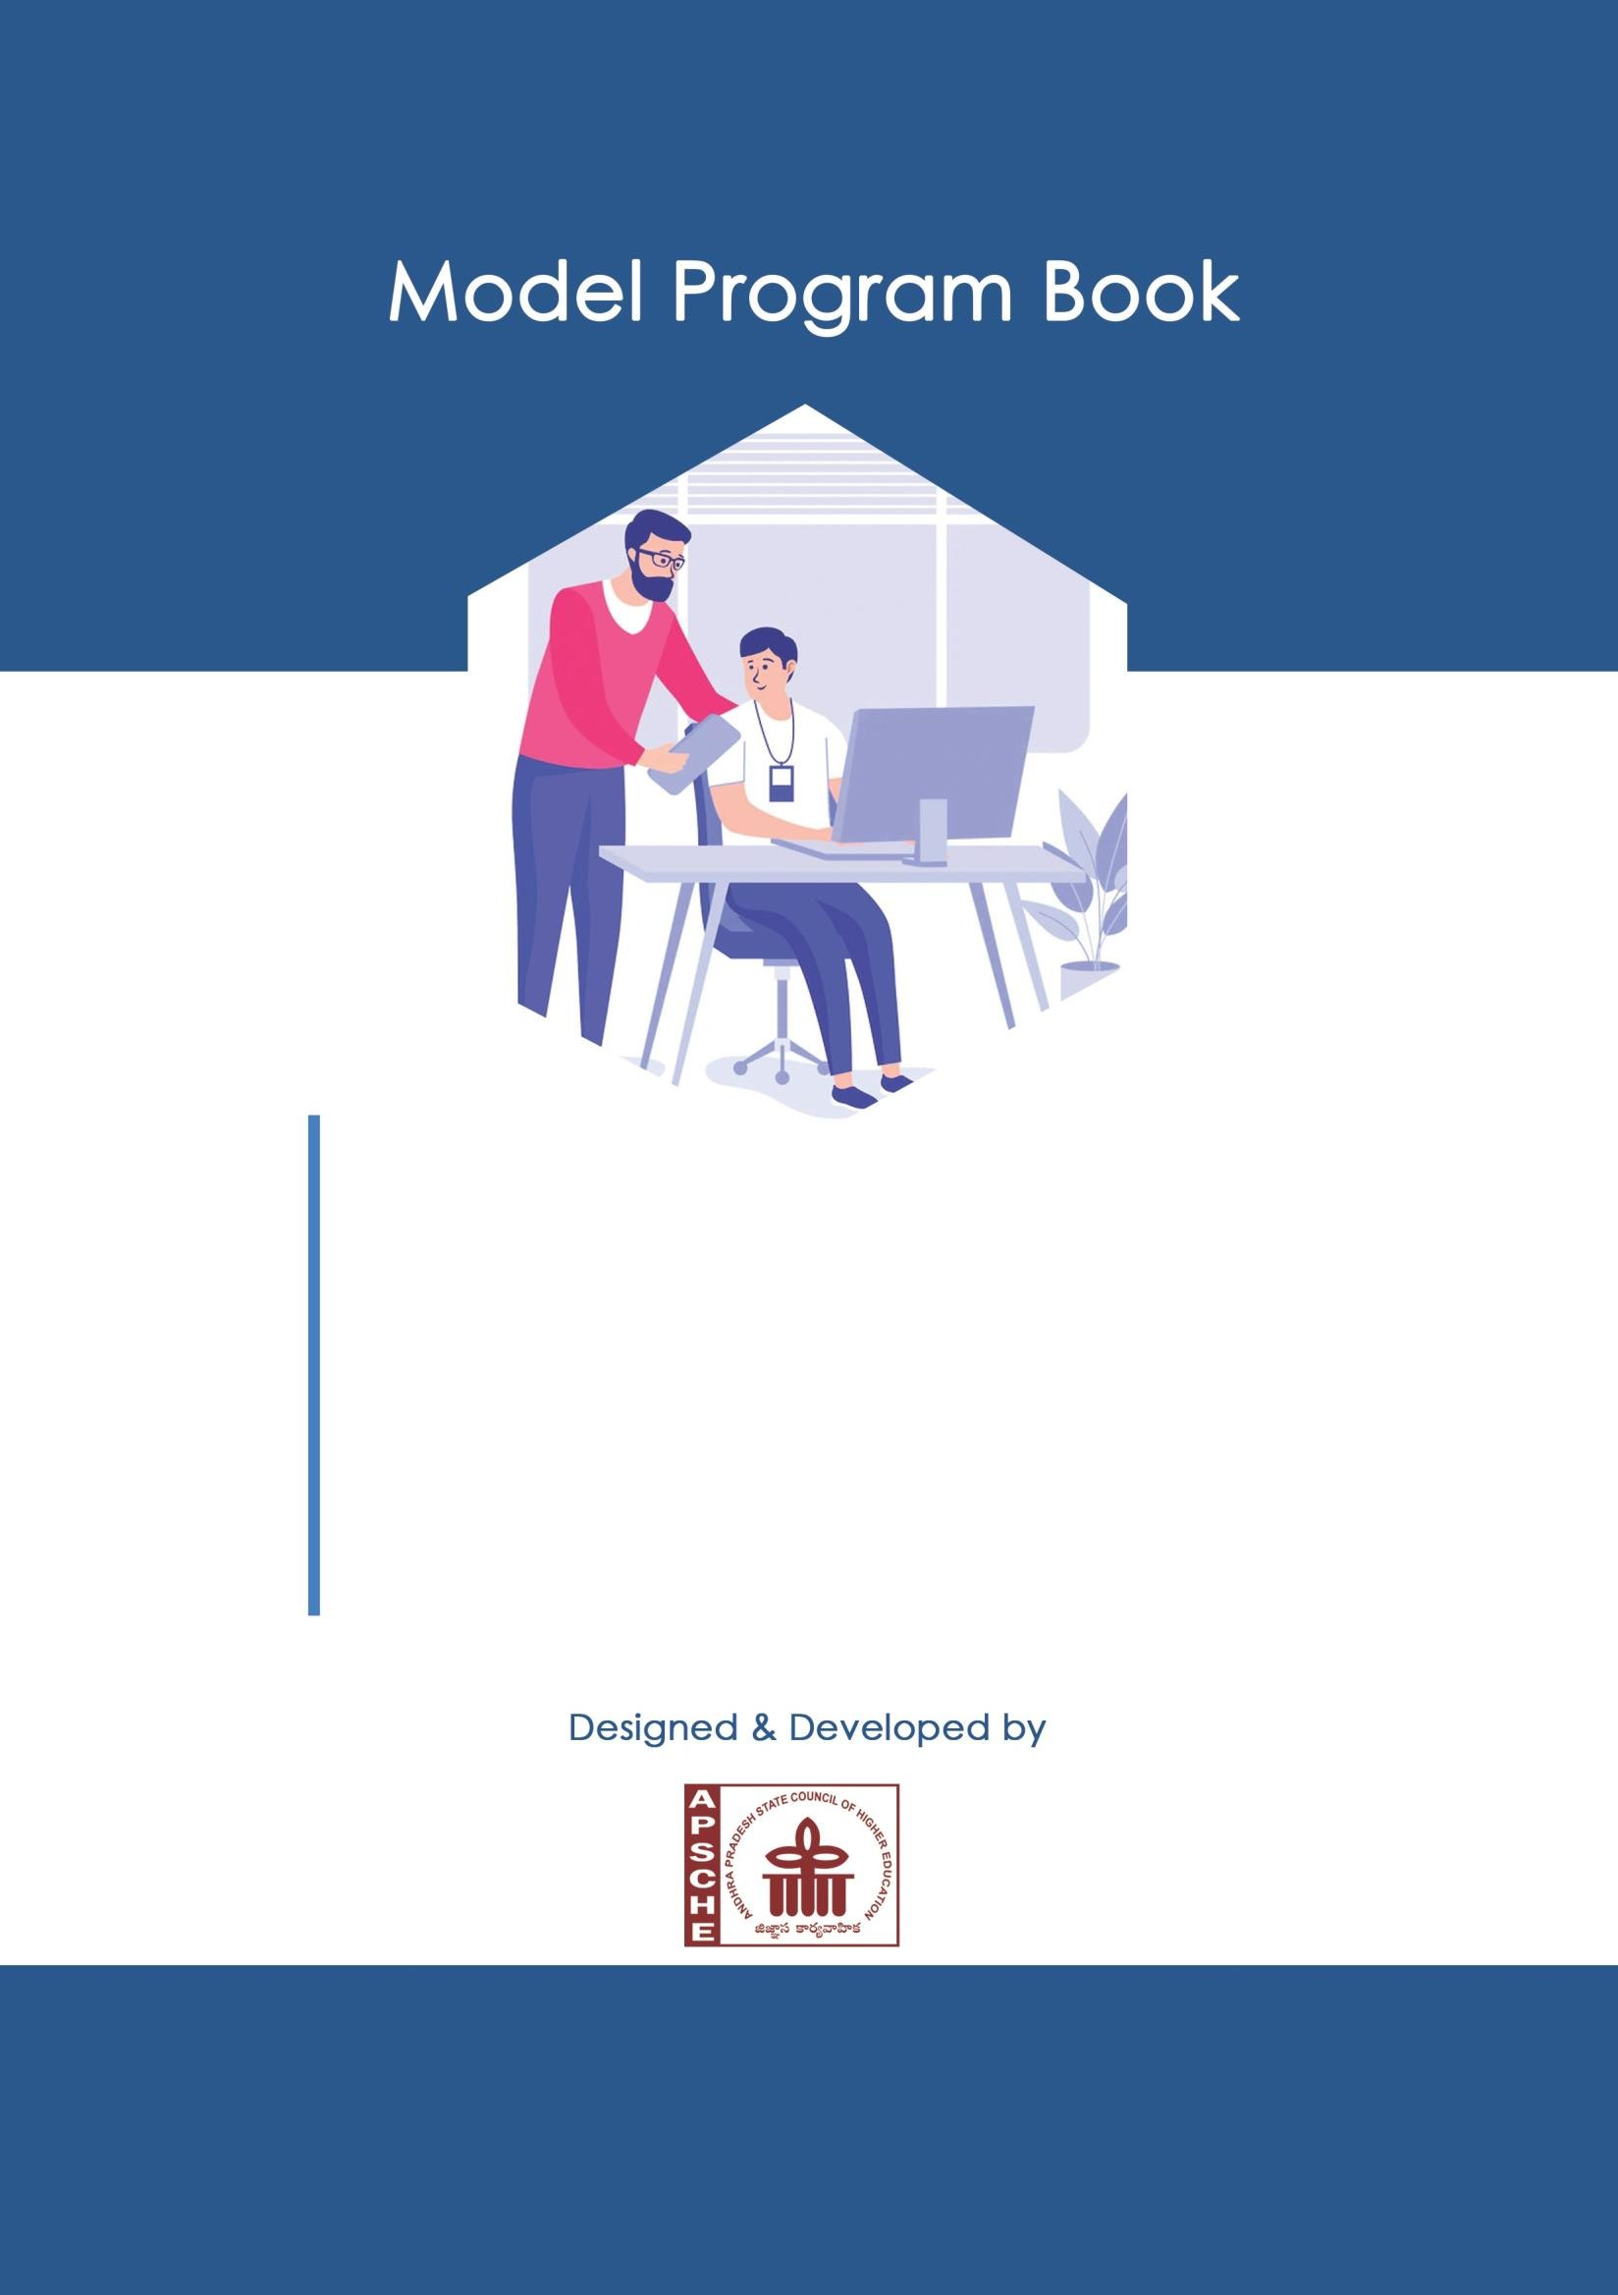

SHORT TERM INTERNSHIP

(On-Site/Virtual)

**ANDHRA PRADESH**

**STATE COUNCIL OF HIGHER EDUCATION**

(A STATUTORY BODY OF GOVERNMENT OF ANDHRA PRADESH)

**PROGRAM BOOK FOR**

**SHORT-TERM INTERNSHIP**

# (Onsite / Virtual)

Name of the Student:M SUCHITRA

Name of the College: KUPPAM ENGINEERING COLLEGE

Registration Number: 20F41A0440

Period of Internship: From: 30/05/2023 To: 04/08/2023

Name & Address of the Intern Organization:SMART INTERNZ

**Jawaharlal Nehru Technological University Anantapur (JNTUA)**

**YEAR (2022-2023)**

# An Internship Report on

**Analyzing the Performance & Efficiency of The Radisson Hotels using Data Visualization Techniques**

*Submitted in accordance with the requirement for the degree of*

# Electronics And Communication Engineering

*Under the Faculty Guide of*

### Dr. P. Ajay Kumar Reddy Sir

*Department of*

**Electronics And Communication Engineering KUPPAM ENGINEERING COLLEGE**

**Submitted by:**

### M Suchitra

### Reg. No:20F41A0440

*Department of*

## Electronics And Communication Engineering KUPPAM ENGINEERING COLLEGE

**Instructions to Students**

Please read the detailed Guidelines on Internship hosted on the website of AP State Council of Higher Education **https://apsche.ap.gov.in**

1. It is mandatory for all the students to complete 2 months (180 hours) of short- term internship either physically or virtually.
2. Every student should identify the organization for internship in consultation with the College Principal/the authorized person nominated by the Principal.
3. Report to the intern organization as per the schedule given by the College. You must make your own arrangements for transportation to reach the organization.
4. You should maintain punctuality in attending the internship. Daily attendance is compulsory.
5. You are expected to learn about the organization, policies, procedures, and processes by interacting with the people working in the organization and by consulting the supervisor attached to the interns.
6. While you are attending the internship, follow the rules and regulations of the intern organization.
7. While in the intern organization, always wear your College Identity Card.
8. If your College has a prescribed dress as uniform, wear the uniform daily, as you attend to your assigned duties.
9. You will be assigned a Faculty Guide from your College. He/She will be creating a WhatsApp group with your fellow interns. Post your daily activity done and/or any difficulty you encounter during the internship.
10. Identify five or more learning objectives in consultation with your Faculty Guide. These learning objectives can address:
    1. Data and Information you are expected to collect about the organization and/or industry.
    2. Job Skills you are expected to acquire.
    3. Development of professional competencies that lead to future career success.
11. Practice professional communication skills with team members, co-interns, and your supervisor. This includes expressing thoughts and ideas effectively through oral, written, and non-verbal communication, and utilizing listening skills.
12. Be aware of the communication culture in your work environment. Follow up and communicate regularly with your supervisor to provide updates on your progress with work assignments.
13. Never be hesitant to ask questions to make sure you fully understand what you need to do your work and to contribute to the organization.
14. Be regular in filling up your Program Book. It shall be filled up in your own handwriting. Add additional sheets wherever necessary.
15. At the end of internship, you shall be evaluated by your Supervisor of the intern organization.
16. There shall also be evaluation at the end of the internship by the Faculty Guide and the Principal.
17. Do not meddle with the instruments/equipment you work with.
18. Ensure that you do not cause any disturbance to the regular activities of the intern organization.
19. Be cordial but not too intimate with the employees of the intern organization and your fellow interns.
20. You should understand that during the internship programme, you are the ambassador of your College, and your behavior during the internship programme is of utmost importance.
21. If you are involved in any discipline related issues, you will be withdrawn from the internship programme immediately and disciplinary action shall be initiated.
22. Do not forget to keep up your family pride and prestige of your College.

<<@>>

# Student’s Declaration

I, **M Suchitra** a student of **Electronics and communication engineering** Program, Reg. No. **20F41A0440** of the Department of **electronics and communication engineering** College do hereby declare that I have completed the mandatory internship from **30 MAY 2023** to **4 AUGUST 2023** in **SMART INTERNZ** (Name of the intern organization) under the Faculty Guideship of **DR. P. AJAY KUMAR REDDY SIR**, Department of **Electronics and communication engineering, Kuppam engineering college**

*(Signature and Date)*

## Official Certification

This is to certify that **M Suchitra** Reg. No.

**20F41A0440** has completed his/her Internship in

**SMART INTERNZ** on **Analyzing the Performance & Efficiency of The Radisson Hotels using Data Visualization Techniques** under my supervision as a part of partial fulfillment of the requirement for the Degree of_**Electronics and communication engineering**_ in the Department of

###### Electronics and communication engineering, Kuppam engineering college

*(Signatory with Date and Seal)*

**Endorsements**

*Faculty Guide*

*Head of the Department*

*Principal*

## Certificate from Intern Organization

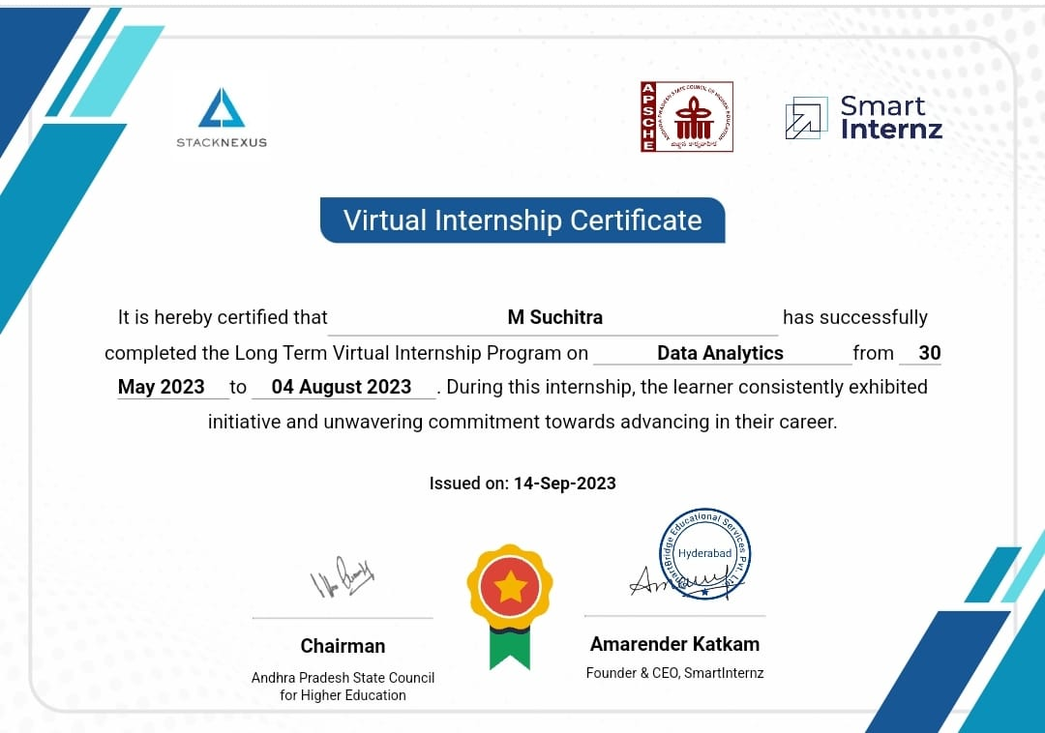

## Acknowledgements

An endeavor of a long period can be successful only with the advice of many well wishers. We take this opportunity to express Our deep gratitude and appreciation to all those who encouraged us for successfully completion of the Project work.

Our special thanks to Our Guide Dr. P Ajay Kumar Reddy.M. Tech, Ph.D.. Associate Professor, Department of ECE, KEC, for his valuable guidance and suggestions in analyzing and testing throughout the period. Until the end of the project.

Our special thanks to Dr. G. N. Kodandaramaiah, Tech, Ph.D., Professor & HOD, Department of ECE, KEC during the progress of Project work, for his timely suggestions and help in spite of his busy schedule.

We Would like to express Our sincere gratitude to Principal Dr. S Sudhakar Babu, Ph.D for his valuable support and encouragement during Project work.

We wish to express Our sincere thanks to Management of Kuppam Engineering for his consistent help and encouragement to complete the Project work.

Finally, I would like to express sincere thanks to internal advisor Faculty Members of E.C.E Department, and Lab technicians, one and all who have helped me to complete the project work successfully.

With regards M.SUCHITRA

## Contents

## Contents

**CHAPTER NO. DESCRIPTION OF CONTENT**

CHAPTER -1 EXECUTIVE SUMMARY

CHAPTER -2 OVERVIEW OF THE ORGANIZATION

CHAPTER -3 INTERNSHIP PART

3.1 Data Collection&Extraction From Database

3.2 Data Preparation

3.3 Data Visualization

3.4 Exploratory Data Analysis

3.5 Dashboard

3.6 Story

3.7 Report

3.8 Performance Testing

3.9 Web Integration

3.10 Project Demonstration &Documentation

CHAPTER -4 LOG SHEETS AND WEEKLY REPORTS

4.1 Activity log sheet and weekly report for the first week

4.2 Activity log sheet and weekly report for the second week

4.1 Activity log sheet and weekly report for the third week

4.1 Activity log sheet and weekly report for the fourth week

4.1 Activity log sheet and weekly report for the fifth week

4.1 Activity log sheet and weekly report for the sixth week

CHAPTER -5 OUTCOMES DESCRIPTION

CHAPTER -6 CONCLUSION

FUTURE SCOPE

REFERENCE

#### CHAPTER 1: EXECUTIVE SUMMARY

* This Project report aims to Provide a Comprehensive analysis of the hotel industry, with a focus on the luxury business hotels Category.
* The report will also explore the challenges faced by Radission and the Importance of incorporating Business and Data intelligence to Regain the market share and revenue.
* The development of an analytics dashboard story has allowed for a Comprehensive analysis of Radission Hotel's Performance and efficiency, Providing Valuable insights for the management team.
* The identified key Performance indicators and metrics, as well as the forecasting models will assist in making data driven decisions to improve market share and Revenue.
* The report will include a detailed description of the analysis dashboard and story that were Created for Radission, which will provide valuable insights for better decision making. The report will also discuss the methodology used in developing the dashboard and story, including data Sources and data cleaning and data analysis techniques.

#### CHAPTER 2: OVERVIEW OF THE ORGANIZATION

**Introduction of the organization:**

* This initiative, in Collaboration with APSCHE aims to build to Job ready talent pool in the Various demanding technologies.
* This Program aims to entrance the employability innovation and Entrepreneurship skills of Student's through hands on, Project-based learning under the guidance of industry mentors. It helps students. acquire technical and Professional Competencies, while working on real-world Challenges and Creating innovative Solutions This Smart internz Program encourages students to think critically and Creatively, and it is designed to provide industry-level training of the challenge level.

**Vision, Mission, and Values of the Organization:**

Vision:

* The vision of smart internz for Students is to empower students with real-world skills and Experience, transcending geographical barries through a dynamic virtual intership Program.

Mission:

* The mission of Smart internz is to provide a transformative tearning environment that include the Connects students with industry experts, fosters Collaboration, and prepares then for future Career Success in a rapidly evolving digital landscape.

Values:

* The specific details depends on the gods and Principles of the smart internz program.

Innovation:

* Embrancing and driving change through Continuous Improvement and Creative solutions.

Inclusivity:

* Creative a diverse and inclusive Community as that values and respects the unique. Perspectives of every individual.

Integrity:

* Upholding the highest ethical standards and forecasting a Culture of honesty and accountability.

Adoptability:

* Respond proactively to the evolving needs of the industry and students, ensuring relevance effectiveness.
* These are the values, vision and mission of Organization.

The policy of the organization in relation to The intern role in smart internz include.

* Code of Conduct
* Confidentiality
* Performance Expectations
* Communication channels
* Evaluation and feedback

Organization structures:

* Typically any Organization structure exclude.

leadership Team

* Departments
* Human Resources
* Program management
* mentorship and Education
* Quality Assurance
* Finance and Administration
* legal and Compliance.

Roles and Responsibilities of the employees the in which the intern is placed:

There are general Overview about it.

* Intern Responsibilities:
* Complete assigned tasks and projects.
* learn and apply relevant skills
* Seek guidance from mentors and Supervisors
* Contribute to learn meeting and discussions
* Adhere to organizational policies and standards
* Mentor Responsibilities:
* Provide guidance and Support to the intern.
* Assign tasks and Projects aligned with learning goals.
* Offer Constructive feedback on the intern's work.
* Ensure a positive and inclusive learning environment.
* Provide technical Support to employee and interns.
* Ensure the efficiency of Security and efficiency of Virtual tools and platforms.

Performance of the Organization in terms of turnover, Profit, market reach and market values:

* The turn over profit; market reach and market value for any Specific organization including Smart internz. For the most accurate and Current information on an organization's perform, I recommend checking their official financial reports, Press releases, or other reliable resources.
* If you have a specific organization or time frame to mind, I Con provide more general insights or on Specific profit turn over accurate information.

Future plans of organization:

* The future plans of smart internz or any other Organization.
* Organization plans Con evolve over time based on market Conditions, industry trends, and Internal Strategies.

#### CHAPTER 3: INTERNSHIP PART

#### This internship the Nota Analytics analysis the hotel industry with a focus on the luxury/business hotels.

* This Analysis explore the challenges faced by Radisson hotels and the importance of incorporating Business and data intelligence to regain than market Share and Revenue.

**There are steps to perform the Analysis of Radission hotels using hotels using data Analytics’**

Define your Problem statement:

* What Problem air you trying to solve ? frame your Problem as a How might we statement.
* This will focus on your brainstorm.

Brainstorm:

* Write down any ideas that Comes that address your Problem statement.

Group ideas:

* Take turns sharing your ideas while clustering Similar or related notes as you go one all Sticky notes have been grouped give each cluster a sentence like label if cluster is bigger than six sticky notes.

Try and see if you and break it up into smaller Sub groups:

Developing on Analytics Dashboard:

* Developing an analytics dashboard is a powerful approach to faciliate understanding and enable the managing director and other stakeholders to take action based on the data a insights.

Analytical Techniques to entrance Radisson Hotels efficiency:

* To improve the Performance and efficiency of Redission Hotels a variety of analytical techniques can be employed these includes identifying key performance.

**• Analyzing and improving Customer Experience:**

* Through analysis Company Can identify areas for Improvement. Implement changes to entrance the Customer experience and ultimately increase customer.
* For Performing the Analysis IBM cogons is used which is suite of business intelligence (B1) and perform management Software tools designed for data Analysis, reporting and dashboards.
* In this IBM cognos Dashboard is a user Interface that Presents information and data in a well- organized and easily Comprehensive format Dashboard's have Various applications in industries such as business, finance manufacturing.

CHAPTER 5: OUTCOMES DESCRIPTION

* A student of short term internship Program from APSCHE virtual internship under this short term internship Program.
* I have choosen to do internship of Data Analytics. The environment of Work (or) classes was very good while explaining and delivering data.
* In this Internship they gave freedom to raise questions if any doughts. I felt that I gained a much more in this enriching experience in this Data Analytics Internship.
* It gave me the whole picture about the Analysis of data using the Radission hotels.
* The trainer are to very good at motivating to enrich Skills and to be active at classes.
* The trainer motivated with many Success stories which inspire me to learnt this Data analytics with more interest.
* I learnt presentation skills Analysis skills and the technical skills to Analyze the data using the data sheets I learnt from my trainers are ability to deal with Various People in different ways.
* They gore me lots of insights in Setting up Professional and educational career.
* They were very kind and helpful that he helped me with the tasks and guiding me in every possible way.
* The Overall work environment is really good and intern ship unit is friendly. The environment of internship is safe and every interactive Trainer were supporter Very well while giving new ideas and also raising the doughts.
* I learnt to analyze the data easily using this internship with help of IBM Cognos. They hour Provide free counts for the students to analyze the data. Using this IBM Cognos it's easy to analysis with different graphs, pie cheats, mops to find locations.
* Finally The Overall environment of internship is really good and internship unit is very friendly while interactive with each and every students. Working with APSHE virtual internship is very Satisfactory and an enlightening experience.

**Describe the real time technical skills you have acquired (in terms of the job related skills and hands on experience)**

* under this short term internship. Ingram on the role of analysizing the performance of Radission Hotels Using Date Analytics have acquired the following skills under the guidance of trainers of data analytics.

**To Analyze the data some of the technical Skills/ steps are used:**

* **Data Analysis Tools:**
* The Proficiency in tools like Python or Specialized tools like IBM Cognos (or) Tablear. But in this we used IBM Cognos as Tool for analying Radission Hotel.
* **Data base management:**
* Understanding the data base for extracting the relevant information from the hotels data repositories.
* **Statistical Analysis:**
* Knowledge of Statistical methods for interpreting data trends and patterns, essential for making informed decisions.
* **Data Pre Processing:**
* Stills to Preprocess raw data to ensure accuracy and reliability in analysis results.
* **Data visualization:**
* Ability to create clean and meaningfull visualizations to communicate finding effective to Stakeholders.
* This visualization technical skills helped me to Analyze data so effectively.
* **Domain knowledge:**
* In this Domain knowledge is familiarity with the hotel industry including kay Performance indicators (KPIs) relevant to Radission to Contextuolize the data.
* **Communication skills:**The ability to Communicate Complex finding in clear and understandable manner to non-technical Stakeholders.
* **Problem Solving:**
* Strong Problem solving skills to address Specific challenges a goals outlined by Radission hotels Using this Data Analytics.
* **Ethical Considerations:**
* Awareness of ethical Consideration in Handling and analyzing Sensitive data, ensuring Compliance with Privacy Regulations.
* These are the technical skills that I have acquired in this internship on the Data Analytics in Analyzing the Performance of Radassion hotels using data Analytics.

Describe the managerial skills you have

In this short term internship Program on the Data Analytics for analysing the Performance of redission Hotels the required following managerial Skill's ( Interms of planning, Analyzing, Project management, Team Collaboration leadership, Problem Solving, Resource allocation, Stakeholder Management, Strategic Thinking, Presentation Skills, Adaptability and ethical decision making). Under the inspirational and timely guidance of Our-trainers and guide. They are as allows

* **Project management :**

Efficiently plan and Organize the analytics Project, Setting clear goals, timelines, and milestone for the internship.

* **Team Collaboration:**

Collaboration among team members and departments, ensuring effective Communication and Coordination throughout the analysis Process**.**

* **Leadership:**

Guide the team with a team with a Clear vision/Providing direction and motivation to achieve the objectives of analyzing Radision hotel performance**.**

* **Problem Solving:**

Quickly identify Challenges o. Roadblocks in the analysis and implement effective**.\**

**Solutions to keep the Project on track :**

**Resource Allocation:**

* Optimize the allocation of Resources Including time tools, and personal, to maximize the efficiency of the Analysis.
* **Quality Assurance:**

Implement quality Control measures to ensure the accuracy and reliability of the data analysis results**.**

* **Presentation skills:**

Effectively communicate findings through Presentation and reports tailoring the information to different audiences, including non-technical stakeholder.

* **Ethical Decision making:**

Navigate ethical Considerations in data analytics, ensuring Compliance with Privacy regulations and maintaining the integrity of the Analysis.

Those are the Managerial skills that I have aquired in this internship of data analysis in the analyzing the Performance of Radisson Hotel. By this the skills like time management, Leadership, team work and workmanship, decision making and performance analysis has been improved with this internship.

**Describe how you could improve your communication skills**

* I have required following forms of Communication skills during internship guidance of our trainers and guide.
* The open communication was one of the strongest and most apparent skills that I learned during my internship.
* When I first started interning I was timid and nervous to ask too many questions because I didn't want to admit that I didn’t Understand or that I need extra help with something from some one.
* Luckily my trainer identified it and made me to get over that fearing quickly, by involving in more and more interaction.
* Her also encouraged me to interact with the many other Student's during the virtual classes.
* To develop ability to Speak freely and understand their problems.
* Along with that I was encouraged to Communicate with higher authorities in order to improve my confidence, levels.
* I used to make a note daily achivements weekly records, key performance indicators which improved my written form of Communication.
* I have developed my oral communication during presentation about the internship done.

**Describe how could you could enhance your abilities in group discussions, participation in teams, contribution as a team member, leading a team/activity.**

* I am M Suchitra I have improved my abilities in group discussions and in team work in the following ways.
* My trainers cluing interning period they had Suggested me to follow below tips always during discussion with opposite person or Co- Intern.
* Always initiative (Condition - if you are familiar with the topic.
* Read more and gather good knowledge about everything during every data basis. So, that I could be with more content and use figures and facts along with examples during discussion.
* I uses always suggested that while Specking logic is implemented important to please others or seek their attension.
* It is also important to maintain good eye contact with all participants and having a good body posture.
* Don't be aggressive or nervous while expressing your views.
* During my interning I learnt that english is not important, but communicating confidently is So impressive thing along with that during teamwork I developed coordination.

**Describe the technological developments you have observed and relevant to the subject area of training**

Being an intern in the APSCHE the following technologies development in the work area.

* Digital technology including the internet, mobile technologies and devices, data analytics, artificial intelligence, digitally-delivered services and apps are changing data analytics.
* This automation and digital technologies allows fine timing of inputs and reduce demand of manual work, like now IBM cognos used to Data-visualization.
* This digital technologies also a helping governments in improving efficiency and effectiveness of existing Programmers and policies and even design better ones In the future too.
* The impact of technology in work place is incredible. It has changed the way traditional work Places used to work.
* Digital technology has increased the efficient vaan's allowing then to meet deadlines to and eventually results in formulated with the datasets Satisfaction of employees.
* It also improved Security measures the workplace and help in keeping important information safe.
* It also help in the monitoring of employers work all the time, which has improved transparency Digital technology helps to keep work fully organized and completly changed the way of mocks of Communication.

Photos &Video Link:

|  |  |
| --- | --- |
| booking %by platform.jpeg | occupancy by day type.jpeg |
| occupancy split by city.jpeg | property by key matrix.jpeg |
| revenue contribution %by category.jpeg | revenue contribution.jpeg |

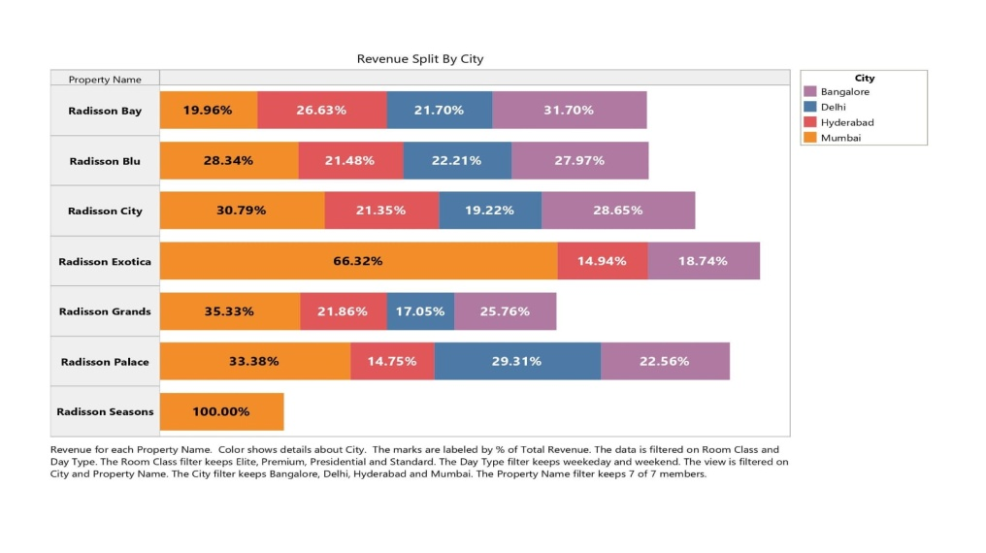

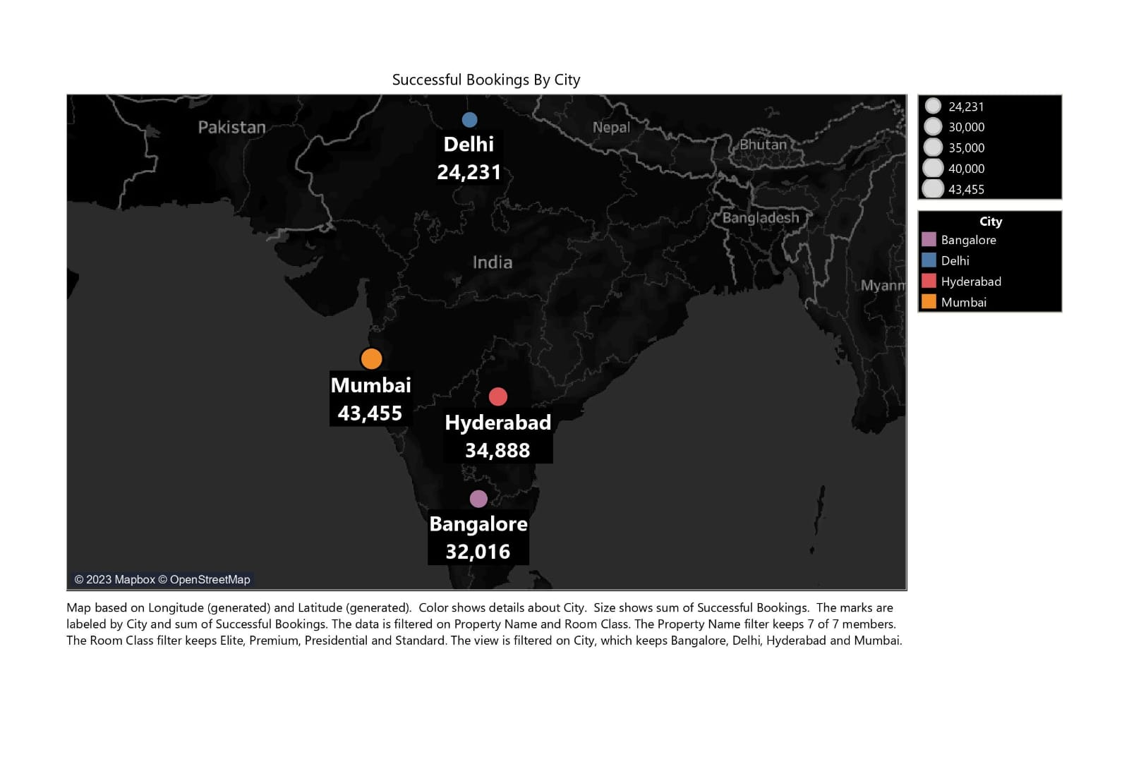

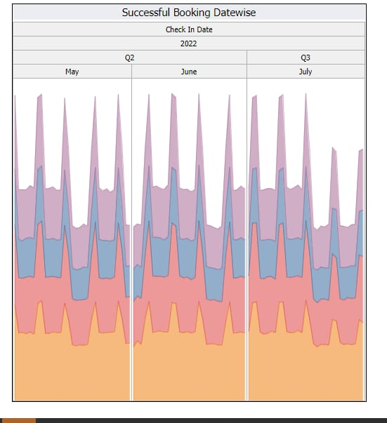

**WEB INTEGRATION**:

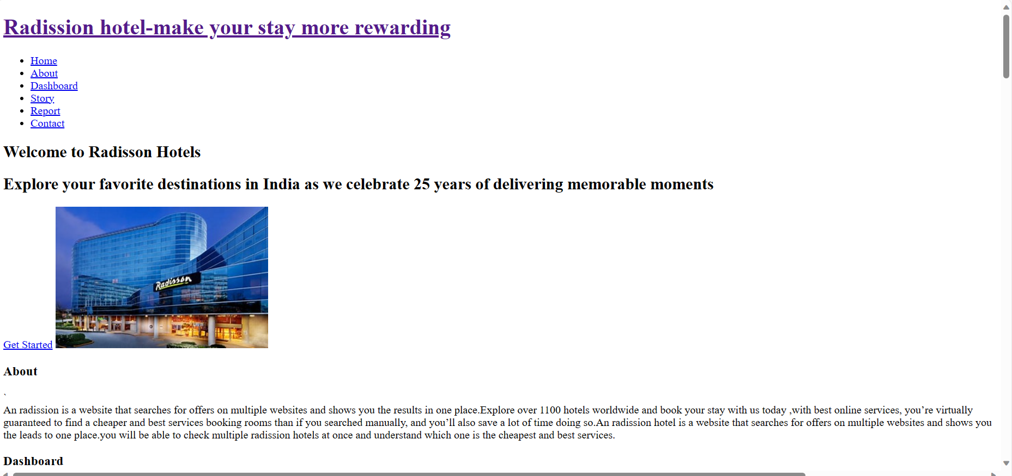

DashBoard Link:

<https://us1.ca.analytics.ibm.com/bi/?perspective=dashboard&pathRef=.my_folders%2FRadission_hotel%2Bdashboard&action=view&mode=dashboard&subView=model0000018a70c1949e_00000007>

**Report Link:**

## <https://us1.ca.analytics.ibm.com/bi/?perspective=story&pathRef=.my_folders%2FRadission_hotel%2Bstory&action=view&sceneId=-1&sceneTime=0>

***Student Self Evaluation of the Short-Term Internship***

**Organization Name & Address:**

|  |  |  |
| --- | --- | --- |
| **Student Name:** |  | **Registration No:** |
| **Term of Internship:** | **From:** | **To :** |
| **Date of Evaluation:** |  |  |

Please rate your performance in the following areas:

**Rating Scale: Letter grade of CGPA calculation to be provided**

|  |  |  |  |  |  |  |
| --- | --- | --- | --- | --- | --- | --- |
| 1 | Oral communication | 1 | 2 | 3 | 4 | 5 |
| 2 | Written communication | 1 | 2 | 3 | 4 | 5 |
| 3 | Proactiveness | 1 | 2 | 3 | 4 | 5 |
| 4 | Interaction ability with community | 1 | 2 | 3 | 4 | 5 |
| 5 | Positive Attitude | 1 | 2 | 3 | 4 | 5 |
| 6 | Self-confidence | 1 | 2 | 3 | 4 | 5 |
| 7 | Ability to learn | 1 | 2 | 3 | 4 | 5 |
| 8 | Work Plan and organization | 1 | 2 | 3 | 4 | 5 |
| 9 | Professionalism | 1 | 2 | 3 | 4 | 5 |
| 10 | Creativity | 1 | 2 | 3 | 4 | 5 |
| 11 | Quality of work done | 1 | 2 | 3 | 4 | 5 |
| 12 | Time Management | 1 | 2 | 3 | 4 | 5 |
| 13 | Understanding the Community | 1 | 2 | 3 | 4 | 5 |
| 14 | Achievement of Desired Outcomes | 1 | 2 | 3 | 4 | 5 |
| **15** | **OVERALL PERFORMANCE** | **1** | **2** | **3** | **4** | **5** |

**Date: Signature of the Student**

##### Evaluation by the Supervisor of the Intern Organization

**Organization Name & Address:**

**Name & Address of the Supervisor with Mobile Number**

|  |  |  |
| --- | --- | --- |
| **Student Name:** |  | **Registration No:** |
| **Term of Internship:** | **From:** | **To :** |
| **Date of Evaluation:** |  |  |

Please rate the student’s performance in the following areas:

Please note that your evaluation shall be done independent of the Student’s self- evaluation

Rating Scale: 1 is lowest and 5 is highest rank

|  |  |  |  |  |  |  |
| --- | --- | --- | --- | --- | --- | --- |
| 1 | Oral communication | 1 | 2 | 3 | 4 | 5 |
| 2 | Written communication | 1 | 2 | 3 | 4 | 5 |
| 3 | Proactiveness | 1 | 2 | 3 | 4 | 5 |
| 4 | Interaction ability with community | 1 | 2 | 3 | 4 | 5 |
| 5 | Positive Attitude | 1 | 2 | 3 | 4 | 5 |
| 6 | Self-confidence | 1 | 2 | 3 | 4 | 5 |
| 7 | Ability to learn | 1 | 2 | 3 | 4 | 5 |
| 8 | Work Plan and organization | 1 | 2 | 3 | 4 | 5 |
| 9 | Professionalism | 1 | 2 | 3 | 4 | 5 |
| 10 | Creativity | 1 | 2 | 3 | 4 | 5 |
| 11 | Quality of work done | 1 | 2 | 3 | 4 | 5 |
| 12 | Time Management | 1 | 2 | 3 | 4 | 5 |
| 13 | Understanding the Community | 1 | 2 | 3 | 4 | 5 |
| 14 | Achievement of Desired Outcomes | 1 | 2 | 3 | 4 | 5 |
| **15** | **OVERALL PERFORMANCE** | **1** | **2** | **3** | **4** | **5** |

**Date: Signature of the Supervisor**

# EVALUATION

#### Internal Evaluation for Short Term Internship (On-site/Virtual)

Objectives:

* To integrate theory and practice.
* To learn to appreciate work and its function towards the future.
* To develop work habits and attitudes necessary for job success.
* To develop communication, interpersonal and other critical skills in the future job.
* To acquire additional skills required for the world of work.

Assessment Model:

* There shall only be internal evaluation.
* The Faculty Guide assigned is in-charge of the learning activities of the students and for the comprehensive and continuous assessment of the students.
* The assessment is to be conducted for 100 marks.
* The number of credits assigned is 4. Later the marks shall be converted into grades and grade points to include finally in the SGPA and CGPA.
* The weightings shall be:
  + Activity Log 25 marks
  + Internship Evaluation 50marks
  + Oral Presentation 25 marks
* Activity Log is the record of the day-to-day activities. The Activity Log is assessed on an individual basis, thus allowing for individual members within groups to be assessed this way. The assessment will take into consideration the individual student’s involvement in the assigned work.
* While evaluating the student’s Activity Log, the following shall be considered

–

* 1. The individual student’s effort and commitment.
  2. The originality and quality of the work produced by the individual student.
  3. The student’s integration and co-operation with the work assigned.
  4. The completeness of the Activity Log.
* The Internship Evaluation shall include the following components and based on Weekly Reports and Outcomes Description

1. Description of the Work Environment.
2. Real Time Technical Skills acquired.
3. Managerial Skills acquired.
4. Improvement of Communication Skills.
5. Team Dynamics
6. Technological Developments recorded.

**MARKS STATEMENT**

**(To be used by the Examiners)**

INTERNAL ASSESSMENT STATEMENT

**Name Of the Student: Programme of Study: Year of Study:**

Group:

**Register No/H.T. No: Name of the College: University:**

|  |  |  |  |
| --- | --- | --- | --- |
| ***Sl.No*** | ***Evaluation Criterion*** | ***Maximum Marks*** | ***Marks Awarded*** |
| 1. | Activity Log | 25 |  |
| 2. | Internship Evaluation | 50 |  |
| 3. | Oral Presentation | 25 |  |
|  | GRAND TOTAL | 100 |  |

Date: Signature of the Faculty Guide

**Certified by**

Date: Signature of the Head of the Department/Principal

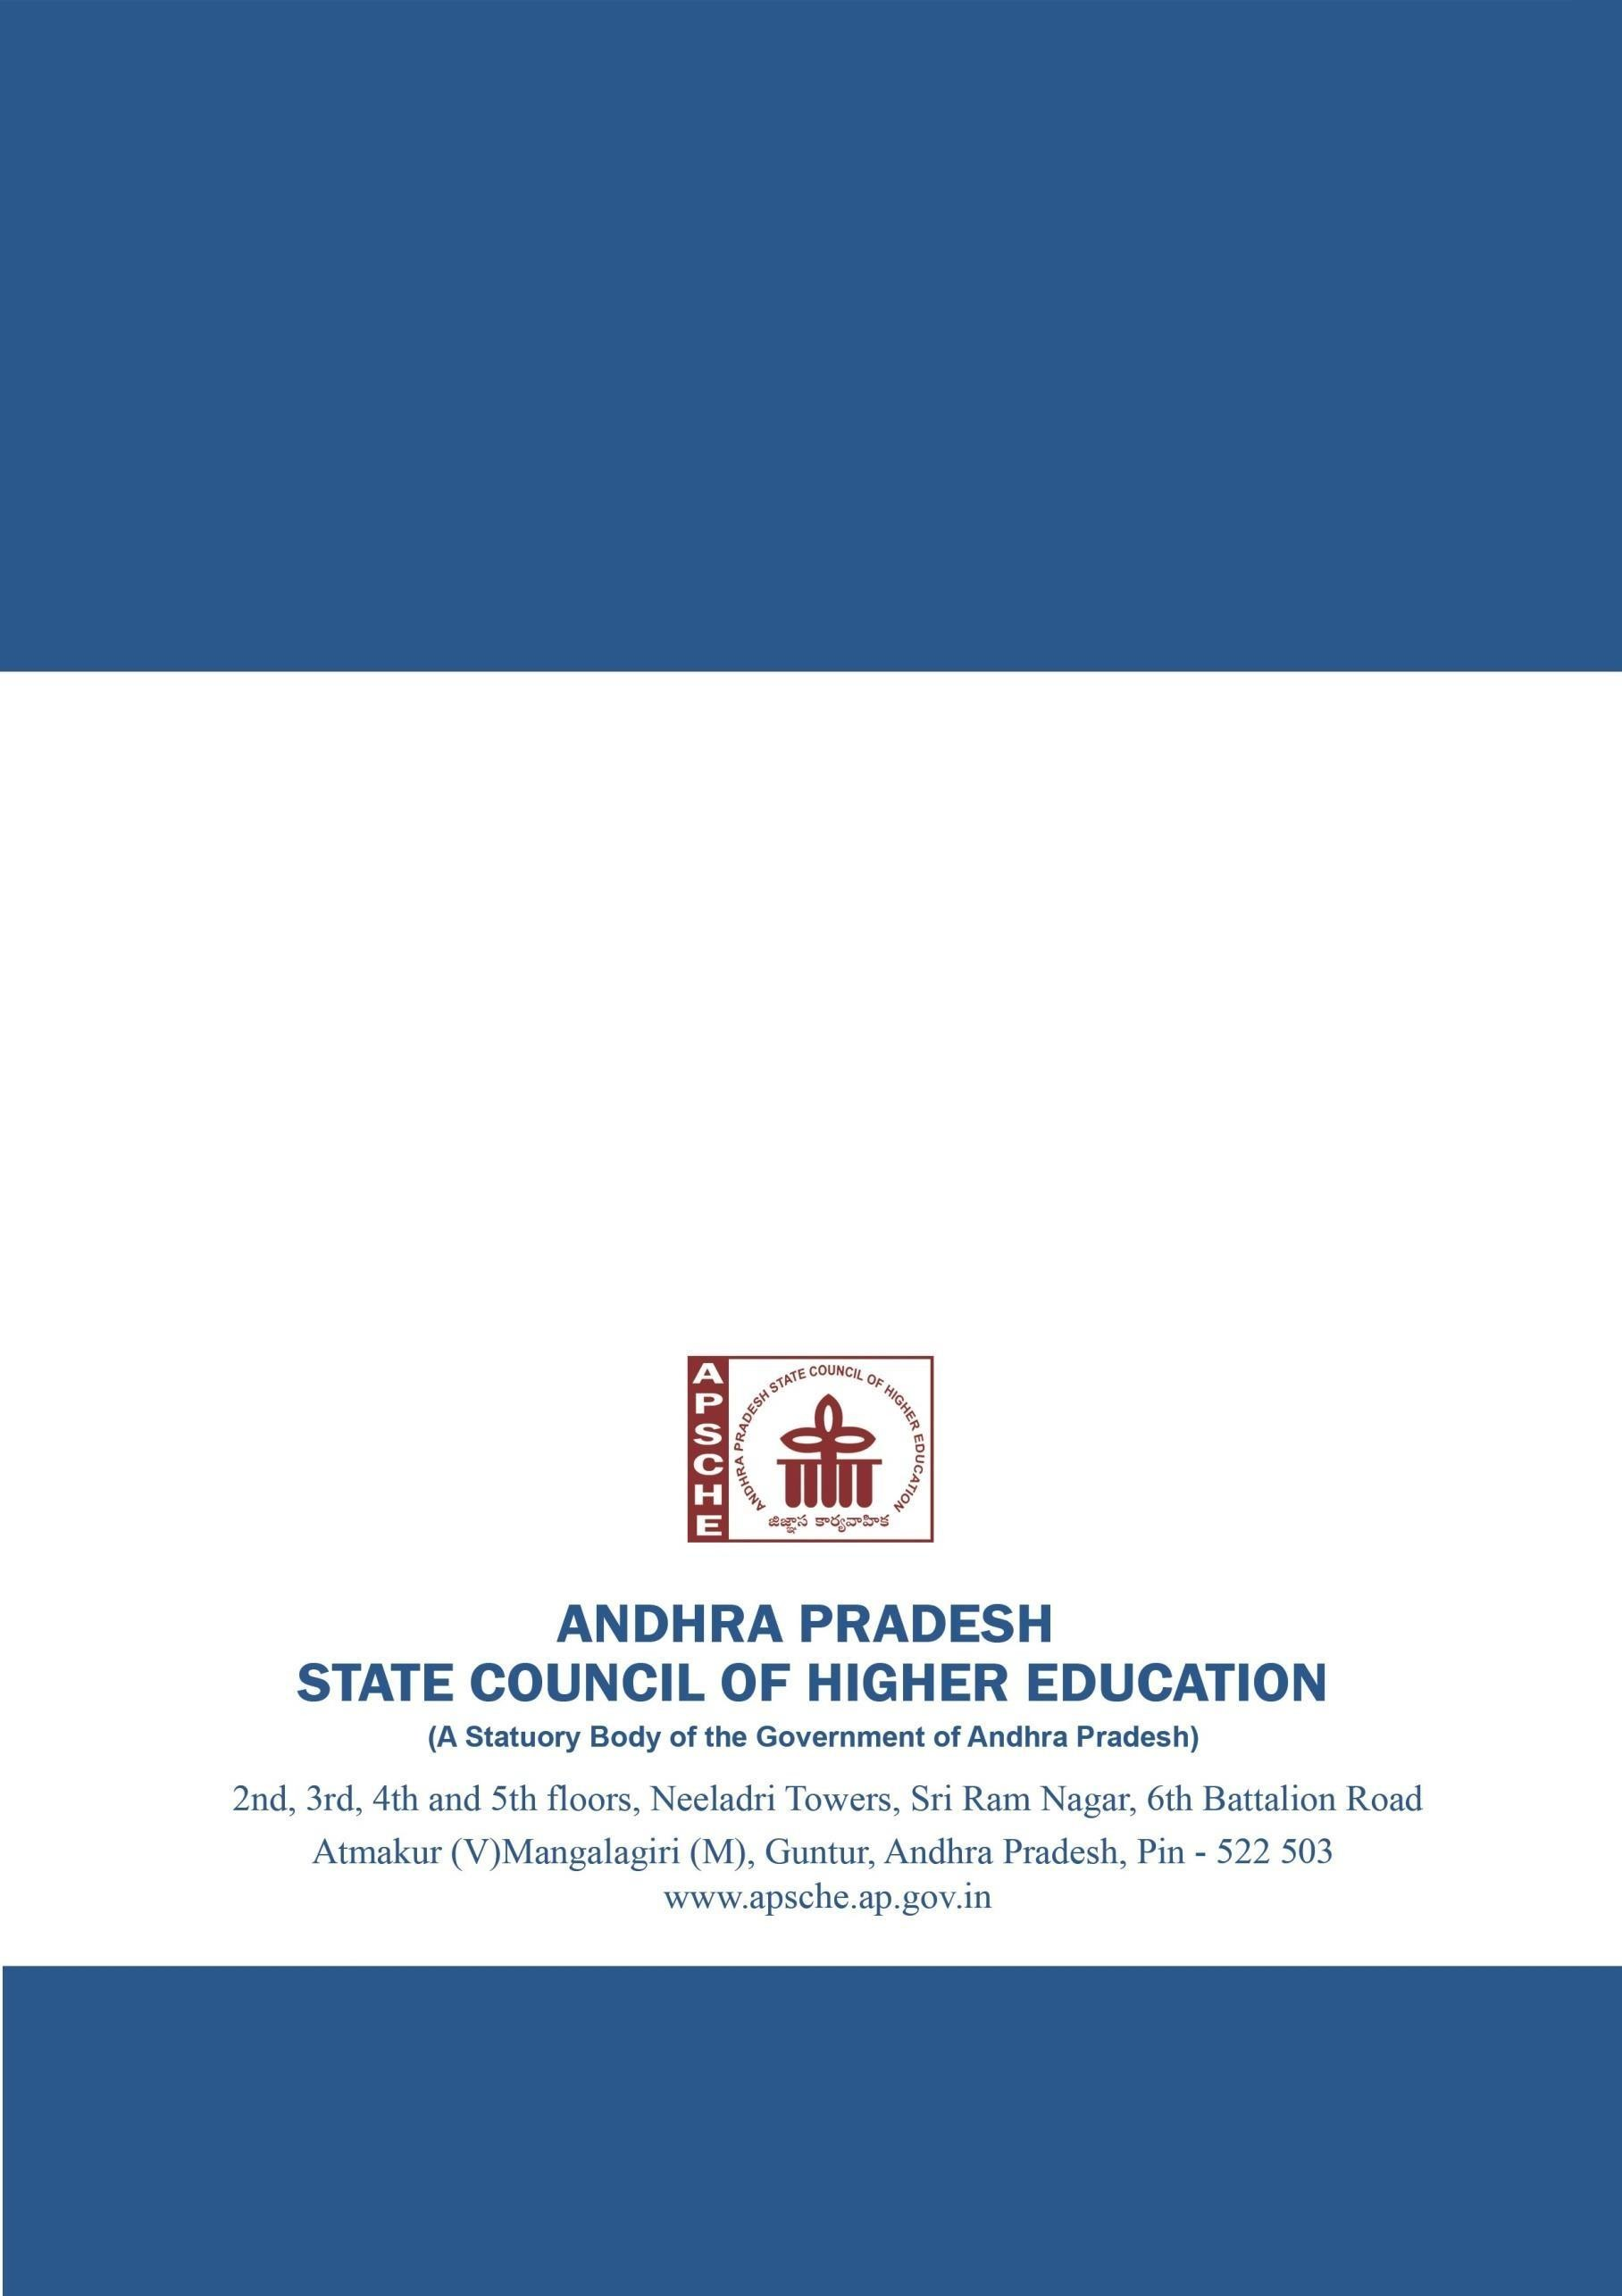Seal: